DIRECTORS PROFILES

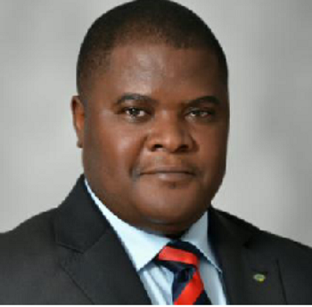

EMMANUEL JACKSON EBUK.

Emmanuel Ebuk is the Treasurer of Codebridge Cooperative Society.
He is founder Landmarkglobal Express, a Business Development and strategy firm. He is a man of many parts. A retired officer of the Nigerian Army, a Counter Insurgency and Terrorism Expert, Business Development guru and Financial Risk Management consultant.
He is a serial entrepreneur who is passionate about youth empowerment and financial freedom. He has worked extensively in the Nigerian Banking and financial services sector where he rose to the position of Assistant General Manager and Chief Risk Officer of one of the major financial institutions in Nigeria.
His educational background includes a Bachelor degree in Electronics Engineering from the prestigious Nigerian Defence Academy, an MBA in International Business Management and an MSc in Corporate Governance from Leeds Beckett University, Leeds, United Kingdom as well as a PhD in Security and Intelligence. He also holds several international certifications in Risk Management and Information Systems Controls.
He is a highly sought after conference speaker and trainer who has presented several papers in the area of Risk Management, Information Systems Control, Counter Terrorism, Business Development and Agriculture.
He is a spirit filled and led Christian who is happily married and his hobbies include chess, golfing, travelling and tennis

